**Accident Detection and Alert System**

**Bachelor of Technology**

**In**

**Computer Science and Engineering**

Submitted by

**Suraj Pattanayak**

**Registration No. – 2202040039**

**Under the esteemed guidance of**

**Prof. Himansu Sekhar Behera**



**DEPARTMENT OF COMPUTER SCIENCE AND ENGINEERING**

**VEER SURENDRA SAI UNIVERSITY OF TECHNOLOGY**

**BURLA, SAMBALPUR-768018**

**Department of Computer Science and Engineering**

**VEER SURENDRA SAI UNIVERSITY OF TECHNOLOGY, BURLA**



**CERTIFICATE**

This is to certify that the project entitled **" Accident Detection and Alert System"** is being submitted by **Mr. Suraj Pattanayak (Regd. No. 2202040039)** from the **Department of Computer Science and Engineering, Veer Surendra Sai University of Technology, Burla**. This report is an original work carried out by him under our supervision and guidance.

**Prof. Himansu Sekhar Behera**

**Date:**

**Head of Department, Supervisor**

**Computer Science and Engineering**

**VSSUT, Burla**

**Department of Computer Science and Engineering**

**VEER SURENDRA SAI UNIVERSITY OF TECHNOLOGY, BURLA**



**CERTIFICATE FOR APPROVAL**

This is to certify that the project report entitled **"Accident Detection and Alert System"** submitted by **Mr. Suraj Pattanayak (Regd. No. 2202040039)**, a student of the **Department of Computer Science and Engineering, Veer Surendra Sai University of Technology, Burla**, has been thoroughly examined and evaluated by us. This report is an original work carried out by the candidate under our supervision and guidance, and it meets the requirements for submission as per the academic guidelines of the university.

Prof. Himansu Sekhar Behera Examiner

**Department of Computer Science and Engineering**

**VEER SURENDRA SAI UNIVERSITY OF TECHNOLOGY, BURLA**



**Declaration**

I hereby declare that the project work entitled "Accident Detection and Alert System" is the result of my original research and effort, carried out under the esteemed supervision of Prof. Himanshu Sekhar Behera, Department of Computer Science and Engineering, Veer Surendra Sai University of Technology, Burla. I confirm that this project is an authentic piece of work and has not been submitted, either in part or in full, for the award of any degree, diploma, or certification at any other institution or university. All sources of information used in this report have been duly acknowledged.

Suraj Pattanayak

Regd No. – 2202040039

**Acknowledgement**

I express my sincere gratitude to my supervisor, Prof. Himanshu Sekhar Behera, for providing me with the opportunity to undertake this project. I am deeply appreciative of his insightful guidance, timely advice, continuous support, and motivation throughout my research. His kindness and invaluable contributions have been instrumental in the successful completion of this work.

I extend my heartfelt thanks to all the faculty and staff members of the Department of Computer Science and Engineering, Veer Surendra Sai University of Technology, Burla, India, for their constant support and assistance. I am especially grateful to Prof. Dipak Kumar Sahoo, Vice-Chancellor, VSSUT, Burla, and Prof. Himanshu Sekhar Behera, Head of the Department, Department of Computer Science and Engineering, for their encouragement and for providing me with the necessary resources and facilities throughout my academic journey.

Finally, I would like to express my deepest gratitude to my family for their unwavering love, encouragement, and support, which have been my greatest source of strength.

Suraj Pattanayak

Regd No. – 2202040039

**Abstract**

The Accident Detection and Alert System project introduces an intelligent platform designed to automatically detect road accidents and immediately notify emergency contacts and response teams. This report outlines the development and implementation of the system, emphasizing its role in addressing critical challenges such as delayed emergency response, lack of real-time accident reporting, and inefficient communication during emergencies. By leveraging sensor-based data from accelerometers, gyroscopes, and GPS tracking, the system ensures accurate accident detection and rapid alert generation.

This study highlights the necessity of an automated, real-time accident response mechanism to enhance road safety and reduce fatalities. The report details the project’s objectives, scope, methodology, and implementation strategies, with a strong focus on system design, sensor integration, alert mechanisms, and regulatory compliance. Through comprehensive usability testing, performance analysis, and user feedback, the system demonstrates significant improvements in emergency response efficiency and overall road safety. Ultimately, this project lays the foundation for a more reliable, real-time, and technology-driven accident detection and alerting ecosystem.

**Table of Contents**

1: Problem statement & list of actions for Accident Detection and Alert System 8

* 1. Objective: 8
  2. Problem Definition 8
  3. List of Actor………………………………………………………………. 9
  4. Conclusion………………………………………………………………… 9

1. Software Requirements Specification (SRS) for Accident Detection and Alert System 10
   1. Introduction 10
   2. Overall Description…………...…………………………………………. 11
   3. External User Requirement…………………………………………......12
   4. Requirement Analysis for Accident Detection Alert System…………...13
   5. System Constraints………………………………………………………16
   6. Conclusion……………………………………………………………….16
2. Entity Relationship Diagram for Accident Detection and Alert System .....17
   1. Objective……………………………………………………………………17
   2. **Entities and Their Attributes**…………………………………………...…17
   3. **Relationships and Their Descriptions**……………………………………19
3. Data Flow Diagram……………………………………………………………20
4. Structured Chart 22
5. Use case Diagram 23
6. Class Diagram 24
7. Object Diagram 25
8. State-Chart Diagram 26
9. Activity Diagram 27
10. Sequence Diagram 28
11. Collaboration Diagram 29

**1. PROBLEM STATEMENT FOR ACCIDENT DETECTION AND ALERT SYSTEM**

* 1. **Objective: -**

Objective of this project is to develop an Accident Detection and Alert System that leverages advanced sensors, GPS, and communication technologies to detect accidents in real-time with low response time during emergency, analyse severity, and provide automated alerts to emergency services, ensuring timely assistance and improved road safety.

* 1. **Problem Statement: -**

The Accident Detection and Alert System is an innovative solution designed to enhance road safety and provide real-time assistance in emergencies. Leveraging technology such as GPS, accelerometers, and communication systems, this project aims to revolutionize accident response by reducing delays and ensuring timely help. This system is especially critical in addressing the growing need for efficient and reliable accident detection and alert mechanisms.

Among the challenges:

**Delayed Emergency Responses:** Traditional accident reporting relies on manual intervention, which often results in delayed emergency responses. This can lead to severe consequences, including loss of life or exacerbation of injuries.

**Lack of Accurate Location Information:** Emergency services frequently struggle to pinpoint the exact location of accidents, leading to delays in assistance and inefficiencies in resource deployment.

**Human Dependency:** Current systems rely heavily on eyewitness reports or manual alerts, which may not always be feasible, especially in isolated or rural areas.

**Difficulty in Identifying Severity:** Traditional methods do not provide adequate information about the severity of an accident, leading to challenges in prioritizing emergency responses.

**Scalability Issues:** For large-scale deployment across regions or nations, traditional systems become resource-intensive and challenging to manage effectively.

**1.3** **List of Actors:**

**Drivers and Passengers:** Individuals who benefit from the system’s real-time alerts and emergency assistance.

**Emergency Services:** Responders who receive detailed, accurate information about accidents, enabling faster and more effective intervention.

**Vehicle Manufacturers:** Companies that can integrate the system into vehicles to enhance safety features and meet regulatory requirements.

**1.4 Conclusion: -**

The Accident Detection and Alert System is a transformative project in the field of road safety. By leveraging advanced technologies and automated processes, it ensures faster emergency responses, reduces dependency on manual reporting, and enhances the overall safety of road users. This system not only saves lives but also fosters a culture of safety and efficiency on the roads, making it an essential tool for modern transportation systems.

**2. Software Requirements Specification (SRS) for Peer-to-Peer Lending System**

**2.1 Introduction**

**2.1.1 Purpose**

This Software Requirements Specification (SRS) document outlines the requirements for the **Accident Detection and Alert System**. The goal of this system is to enhance road safety by automatically detecting accidents, assessing their severity, and notifying emergency contacts and services. The system will leverage sensor data, GPS tracking, and automated alerts to improve response times and minimize casualties.

**2.1.2 Document Conventions**

This document follows standard SRS formatting guidelines, including:

* **Bold headings** for major sections.
* **Numbered and bulleted lists** for structured organization.

**2.1.3 Intended Audience and Reading Suggestions**

This document is intended for the following stakeholders:

* End Users (Drivers and Motorcyclists): Understand how the system detects and reports accidents.
* Emergency Responders: Use GPS tracking for quick response.
* IT Professionals and Developers**:** Focus on system architecture, sensor integration, and database management.
* Insurance Providers: Analyse stored accident data for claim processing.

**2.1.4 Product Scope**

The **Accident Detection and Alert System** aims to improve road safety by providing an automated platform for accident detection, severity analysis, and emergency response. Key system capabilities include:

* Real-time accident detection using sensor data.
* Automated emergency alerts with precise GPS location.
* Severity analysis for prioritizing response efforts.
* Integration with smart devices such as smartphones and helmets.
* Secure data storage for accident analysis and reporting.

**2.2 Overall Description**

**2.2.1 Product Perspective**

The **Accident Detection and Alert System** is a standalone system designed to integrate with smart devices and in-vehicle systems. It uses real-time sensor data to detect accidents and trigger alerts. The system ensures quick and accurate response times by providing emergency services with essential information.

**2.2.2 Product Functions**

* Accident Detection: Uses accelerometers, gyroscopes, and speed sensors to detect sudden impacts and rollovers.
* Automated Alert System: Sends emergency alerts (by the help of API call) with accident details and location.
* Severity Analysis: Assesses accident impact based on sensor data.
* Real-Time GPS Tracking: Provides responders with the exact accident location.
* Multi-User Notifications: Notifies emergency services, family members, and insurance providers.
* Integration with Devices: Connects with smartphones, smart helmets, and vehicle systems.
* Data Storage: Maintains accident records for analysis and reporting.

**2.2.3 User Classes and Characteristics**

* Drivers and Motorcyclists: Primary users, rely on automated detection and alert features.
* Emergency Services: Use GPS tracking for rapid response.
* Insurance Companies: Analyse accident data for claim processing.
* Developers and System Administrators: Maintain and update the system.

**2.2.4 Operating Environment**

* Platform: Mobile application and cloud-based system.
* Supported Devices: Smartphones, smart helmets, and in-vehicle systems.
* Database: PostgreSQL/MySQL for secure data storage.
* Connectivity: Requires GPS and internet access for real-time functionality.

**2.2.5 Design and Implementation Constraints**

* Regulatory Compliance: Must adhere to road safety and data privacy laws.
* Hardware Limitations: Performance should align with mobile and embedded system capabilities.
* Integration with Third-Party Services: Must support APIs for GPS tracking, emergency contacts, and insurance providers.
* Security Considerations:
  + Encrypted authentication for users.
  + Secure data transmission for emergency alerts.

**2.2.6 Assumptions and Dependencies**

* Users must have a smartphone or a compatible smart device.
* Reliable internet and GPS connectivity are necessary for real-time tracking and alerts.
* Compliance with local road safety and privacy regulations is mandatory

**2.3 External Interface Requirements**

This section outlines the external interface requirements for the Accident Detection and Alert System, covering the user interface, hardware interface, software interface, and communication interface.

**2.3.1 User Interface**

The system provides a user-friendly mobile application with intuitive navigation and real-time alerts. Key UI elements include:

* Dashboard: Displays real-time status, last known location, and emergency contacts.
* Accident Detection Alert: Pop-up notifications with GPS location and severity level.

**2.3.2 Hardware Interface**

The system interacts with various hardware components for accurate accident detection and alerting. Key hardware interfaces include:

* Accelerometer and Gyroscope Sensors: Used for detecting sudden impact and motion anomalies.
* GPS Module: Captures real-time location data.
* Communication Modules (Cellular/Wi-Fi/Bluetooth): Facilitates sending alerts to emergency contacts and responders.

**2.3.3 Software Interface**

The system must be compatible with various software platforms and services for seamless operation. Key software interfaces include:

* APIs: Integration with third-party services such as Google Maps API for GPS tracking and Twilio API for SMS alerts.
* Database: PostgreSQL/MySQL used for storing accident records and user data.
* Cloud Services: AWS/GCP for backend processing and real-time communication.

**2.4 Requirement Analysis**

**2.4.1 Introduction**

This section outlines the requirements for the Accident Detection and Alert System. The purpose of this system is to enhance road safety by detecting accidents in real-time and ensuring prompt communication with emergency services. The system will leverage GPS, accelerometers, gyroscopes, and communication technologies to accurately detect accidents, analyse their severity, and automate the alerting process. It aims to reduce response times, improve scalability, and ensure reliable assistance during emergencies, particularly in areas where manual intervention is delayed or unavailable.

**2.4.2 Functional Requirements**

The system shall meet the following functional requirements:

**R.1 Accident Detection**

Description: The system uses sensors such as accelerometers, gyroscopes, and vehicle data to identify sudden impacts, rollovers, or other indicators of accidents.

Input: Sensor data (accelerometer, gyroscope, vehicle speed).

Output: Accident detection alert triggered.

Processing: The system continuously monitors sensor data and detects anomalies indicative of accidents.

**R.2 Automated Alert System**

Description: Upon detecting an accident, the system automatically sends alerts to pre-configured emergency contacts and services, including the GPS location of the accident site.

Input: Accident detection signal, GPS location.

Output: Emergency alert sent to contacts and emergency services.

Processing: The system retrieves the user's emergency contact list and sends notifications via SMS, email, or API-based alerts.

**R.3 Severity Analysis**

Description: The system analyses the severity of an accident based on sensor data, including speed changes, force of impact, and vehicle orientation, to prioritize emergency responses.

Input: Impact force, speed change, vehicle orientation.

Output: Categorized severity level (minor, moderate, severe).

Processing: The system classifies accident severity using predefined thresholds and risk assessment models.

**R.4 Real-Time GPS Tracking**

Description: The system provides real-time GPS tracking to locate the accident site and guide emergency responders.

Input: GPS coordinates of the accident location.

Output: Live location updates shared with responders.

Processing: The system fetches real-time GPS coordinates and transmits them to emergency responders.

**R.5 Integration with Devices**

Description: The system integrates with smartphones, smart helmets, or in-vehicle systems to ensure accessibility and widespread adoption.

Input: Device data, Bluetooth/Wi-Fi connection.

Output: System activation and data synchronization.

Processing: The system establishes a connection with external devices and synchronizes real-time accident data.

**R.6 Multi-User Notification**

Description: The system notifies multiple stakeholders, including emergency services, registered contacts, and insurance providers.

Input: Accident report, emergency contact list.

Output: Notifications sent to designated stakeholders.

Processing: The system uses a multi-tier notification mechanism to ensure all relevant parties are informed promptly.

**R.7 Data Storage**

Description: The system stores accident-related data, including timestamps, severity metrics, and location, for further analysis and reporting.

Input: Accident details (time, severity, location).

Output: Securely stored accident records for analysis.

Processing: The system encrypts and stores accident data in a secure database for retrieval and reporting

| **Functional Requirement** | **Priority** |
| --- | --- |
| Accident Detection | High |
| Automated Alert System | High |
| Severity Analysis | High |
| Real-Time GPS Tracking | High |
| Integration with Devices | High |
| Multi-User Notifications | Medium |
| Data Storage | Medium |

**2.4.3 Non-Functional Requirements**

**N.1 Performance Requirements**

N.1.1 The system shall process and respond to accident events within 5-10 seconds, ensuring minimal latency in sending alerts.

**N.2 Scalability Requirements**

N.2.1 The system shall be scalable to support thousands of users and vehicles across multiple regions, maintaining performance and reliability.

**N.3 Security Requirements**

N.3.1 The system shall encrypt all transmitted data, including user locations and emergency alerts, to ensure privacy and prevent unauthorized access.

**N.4 Usability Requirements**

N.4.1 The system shall provide a user-friendly interface for drivers, passengers, and emergency responders, with simple configuration and clear notifications.

**N.5 Reliability Requirements**

N.5.1 The system shall maintain high uptime and continue functioning even in adverse network conditions using offline storage for delayed alerts.

**N.6 Maintainability Requirements**

N.6.1 The system shall use modular and well-documented code to facilitate updates, bug fixes, and future feature integrations.

**2.5 System Constraints**

**Hardware Constraints**

1. **Device Dependency**
   * The system will rely on sensors (e.g., accelerometers, GPS modules) installed in vehicles or smartphones, which may vary in accuracy depending on the hardware used.
2. **Network Connectivity**
   * The system’s real-time alerting functionality requires an internet or cellular connection, limiting its functionality in remote areas with poor or no coverage.
3. **Resource Limitations**
   * The system’s performance may depend on the computational resources available on devices or servers, especially in large-scale deployments.

**Software Constraints**

1. **Platform Compatibility**
   * The system must be compatible with major mobile operating systems (Android, iOS) and support integration with emergency response platforms.
2. **Data Privacy Compliance**
   * The system must comply with data privacy regulations (e.g., GDPR) to ensure secure handling of personal and location data.

**2.6 Conclusion**

This requirement analysis outlines the functional and non-functional requirements for the Accident Detection and Alert System. By leveraging advanced technologies and addressing challenges such as scalability, reliability, and performance, the system provides a robust solution to improve road safety

and ensure faster emergency responses. It is designed to save lives, reduce response times, and promote safer transportation across diverse regions.

**3. Entity Relationship Diagram for Accident Detection and Alert System**

**3.1 Objective:** -

Understanding the Entity Relation Model for Accident Detection and Alert System.

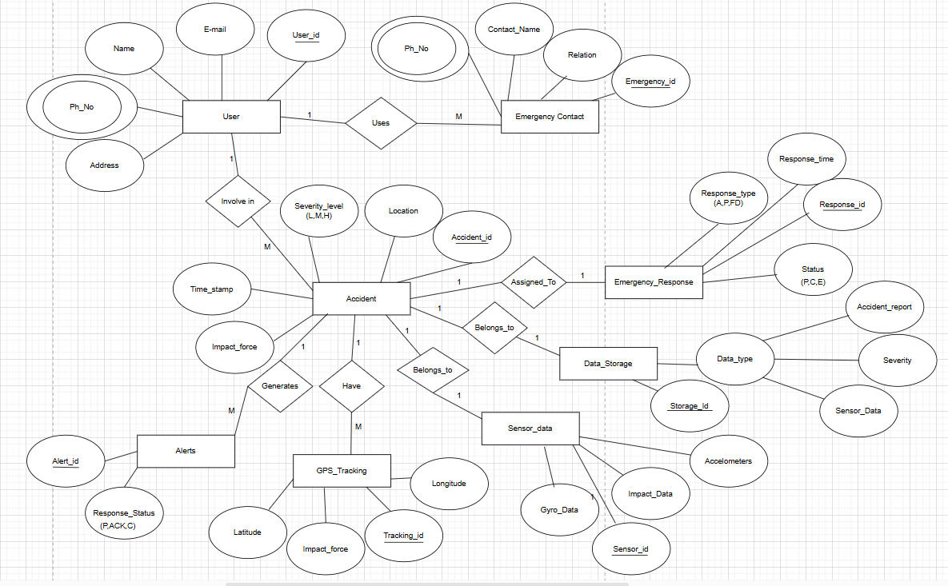

**3.2 Entities and Their Attributes**

**3.2.1 User**

* User Id
* Name
* Email
* Phone Number
* Address

**3.2.2 Emergency Contact**

* Emergency Id
* Contact Name
* Phone Number
* Relation

**3.2.3 Accident**

* Accident Id
* Timestamp
* Location
* Severity Level *(L, M, H)*
* Impact Force

**3.2.4 Alert**

* Alert Id
* Response Status *(P, Ack, Res)*

**3.2.5 Emergency Response**

* Response Id
* Responder Type *(Amb, Police, Fire Dept)*
* Response Time
* Status

**3.2.6 GPS Tracking**

* Tracking Id
* Latitude
* Longitude
* Timestamp

**3.2.7 Sensor Data**

* Sensor Id
* Accelerometer Data
* Gyroscope Data
* Impact Force

**3.2.8 Data Storage**

* Storage Id
* Data Type

**3.3** **Relationships and Their Descriptions**

1. User → Accident *(One-to-Many)*

2. User → Emergency Contact *(One-to-Many)*

3. Accident → Alert *(One-to-Many)*

4. Accident → Emergency Response *(One-to-One)*

5. Accident → GPS Tracking *(One-to-Many)*

6. Accident → Sensor Data *(One-to-One)*

7. Accident → Data Storage *(One-to-One)*

**4. Data Flow Diagram:**

**4.1 Objective**

Creating Data Flow Diagram for Peer-To-Peer Lending system showcasing all the processes, entities and transitions.

* 1. **DFD Level-0**

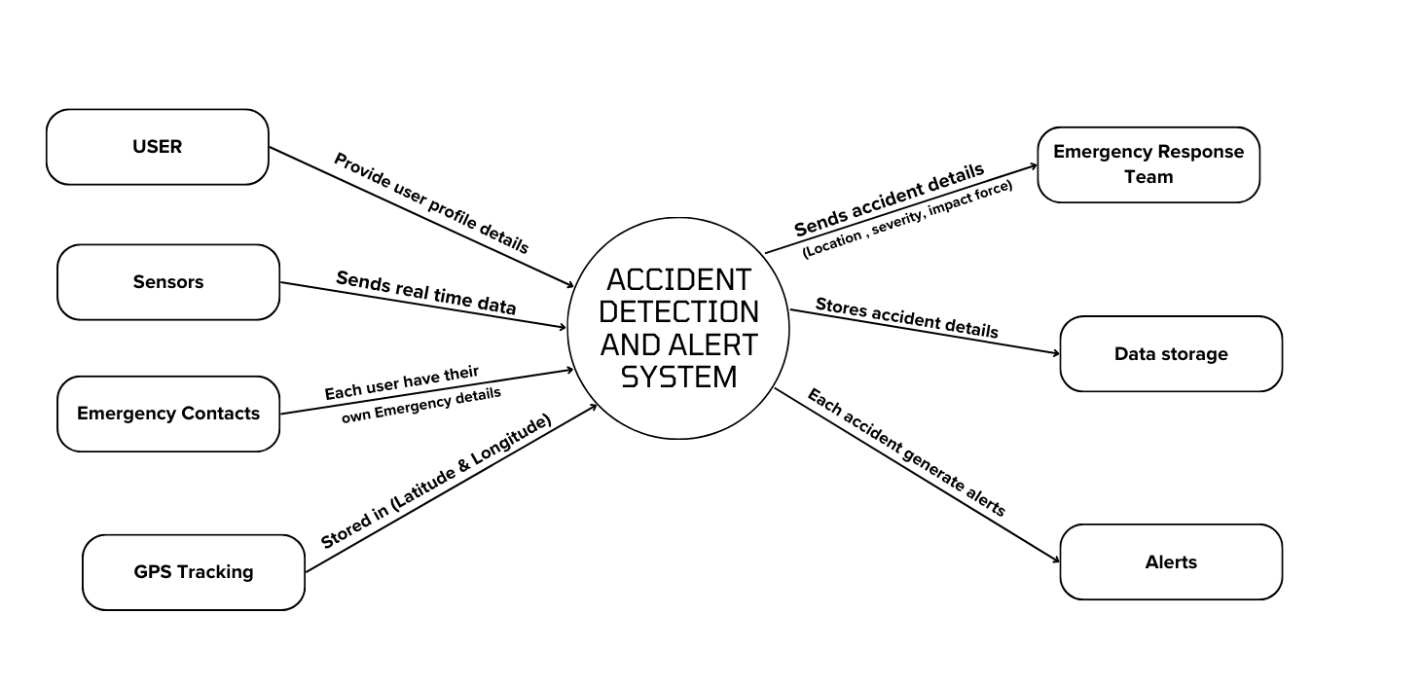

**4.3 DFD Level-1**

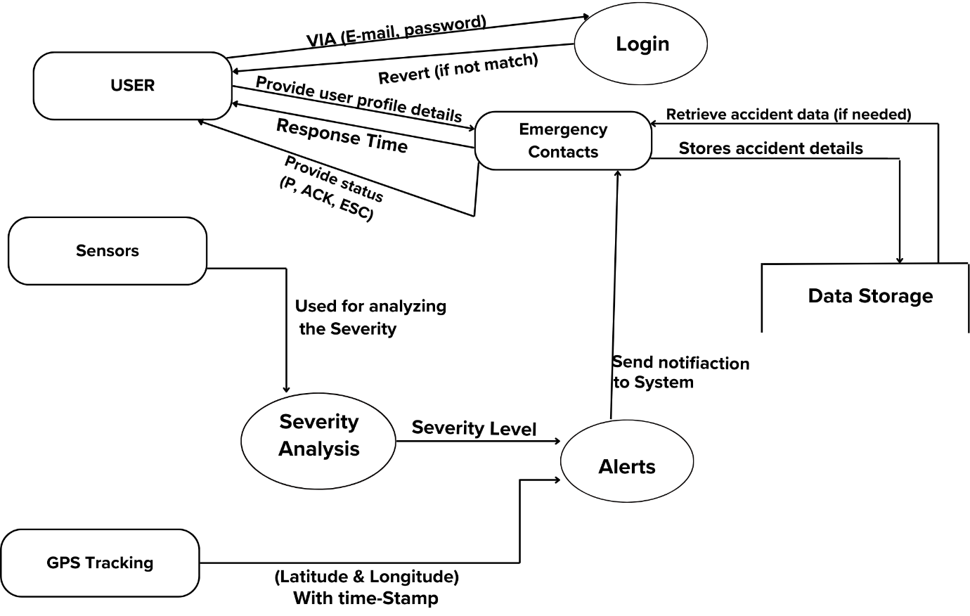

**4.4 DFD Level-2**

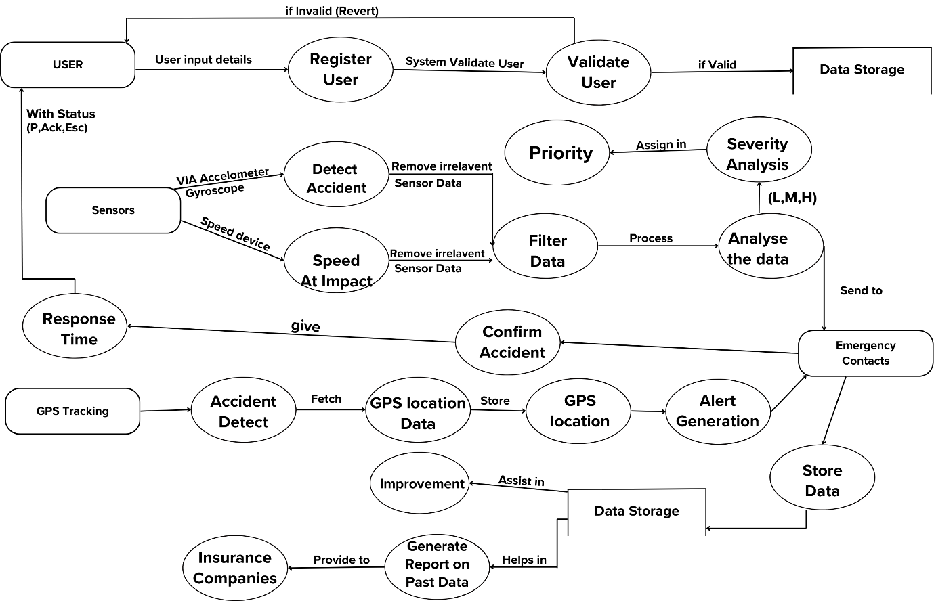

**5. Structure Chart**

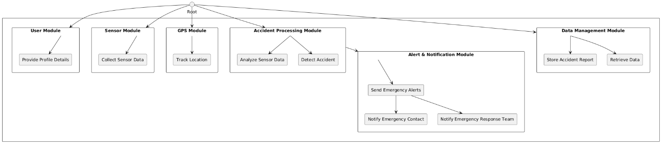

**6. Use-Case Diagram**

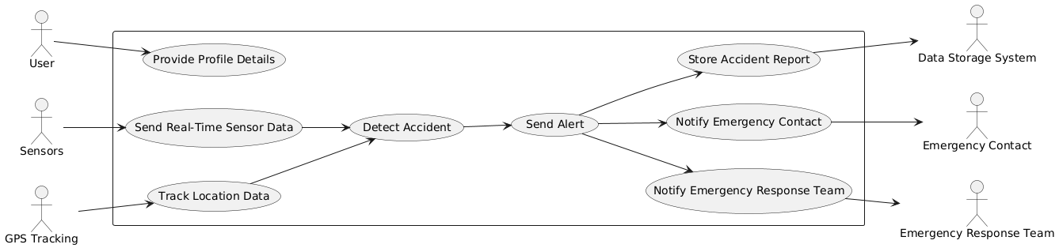

**7. Class Diagram**

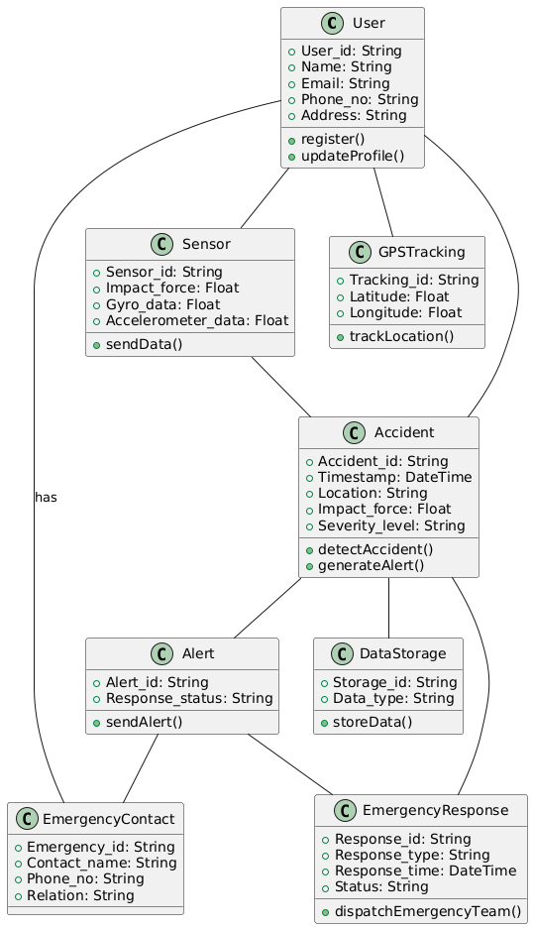

**8. Object Diagram**

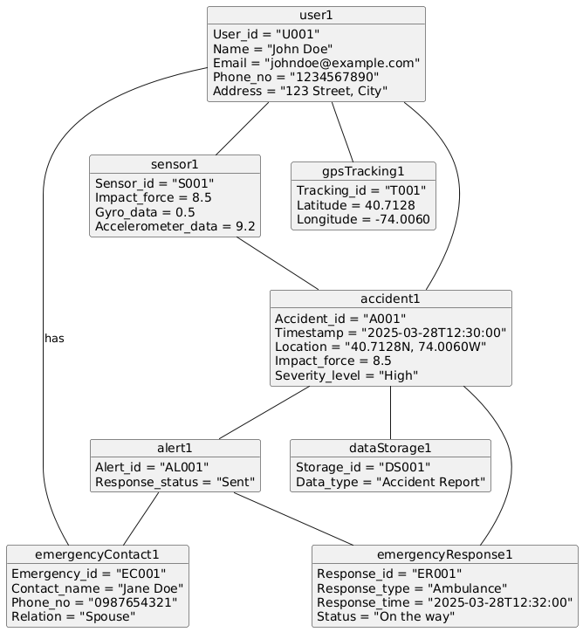

**9. State-Chart Diagram**

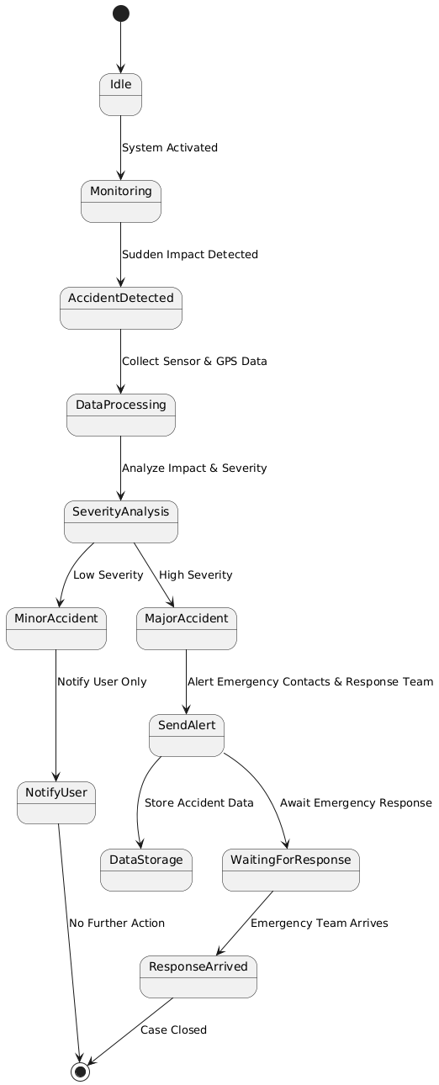

**10. Activity Diagram**

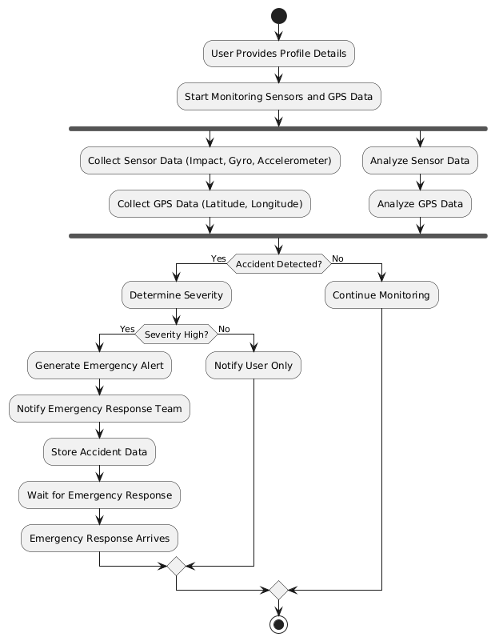

**11. Sequence Diagram**

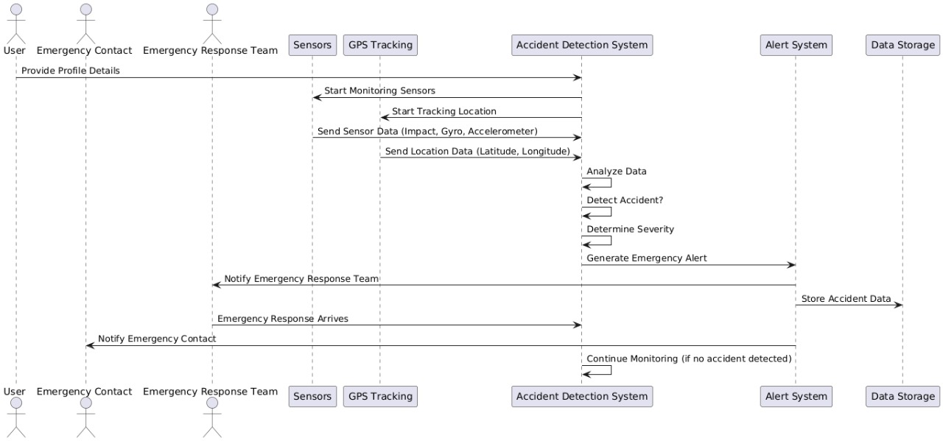

**12. Collaboration Diagram**

